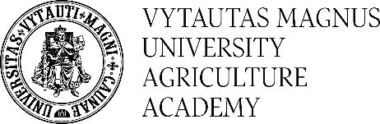

REGISTRATION FORM
for the 2nd INTERNATIONAL CONFERENCE
‘NEW TRENDS IN FOOD SAFETY AND QUALITY‘
Akademija, June 12 – 14, 2019

Please register here for abstract submission or participation

First name:
Second name:
Second name:
Select track:
Sustainable growing technologies and methods used for the improvement of food raw materials
Innovative and perspective raw materials and food products (agriculture and forestry resources for food)
Paper title:
Co-author(s):
Name of University/Institution:
Address:
City:
Country:
Postal / Zip Code
Contact e-mail:

Type of participation | I am intended to provide presentation
 | I am intended to provide poster

Conference Fee:
I will pay registration fees: 150 EUR (until 1th March, 2019), for PhD students – 80 EUR;
180 EUR (after 31st March, 2019), for PhD students – 90 EUR; accompanying person 60 EUR.

