Title of the article (Times New Roman, 14 pt, Bold)
Name Surname (Times New Roman, 12 pt, Bold)
Vytautas Magnus University (Times New Roman, 10 pt, Italic)
Annotation in full length line (Times New Roman, 8 pt, Normal, First line 0,6 cm)
Environmental acoustic noise, Sound pressure level, Traffic noise (Times New Roman, 8 pt, Italic, First line 0,6 cm)
18 pt, Section Break

Introduction (Times New Roman, 10 pt, Bold)
This paper presents a study of the estimation, and the variability of quantitative and qualitative factors from traffic induced law and very low noise on the living environment.
Methods (10 pt, Bold)
The acoustic noise emission from highway traffic is estimated according to ISO 1996 standard: specified by L_{A,eq,T} (equivalent continuous A-weighted sound pressure level over duration T) and LAN (percentle level), which are estimated.
Results and Discussion (10 pt, Bold)
This method has been applied to determine noise generated from traffic. A noise assessment study was performed in the territory of Kaunas – Klaipėda, VIA Baltica Kaunas – Marijampolė, in the suburbs of Kaunas City region where the noise barriers are located, according requirements of Standard LST ISO 1996:1993, LST ISO 7196 and recommendations HN 33:2011 were satisfied (HN 33:2011).
Table 1. Worksheet of calculation of QAI according to standartised noise criteria NC-55 (8 pt., Centered, Normal)
Frequency range |  | Measured SPL in octave bands L_{pi, oct}, dB, at the distance r, m from noise source
Octave band frequency | Frequency range | Machinery | Highway traffic  flow
f_{oct, i} | (L,M,H) | r=7,5m | r=7,5m | r=150m
16Hz  31,5Hz  63Hz  125Hz  250Hz  500Hz  1000Hz  2000Hz  4000Hz  8000Hz | LF  MF  HF | 79  77  63  58  62  52  62  56  53 | 84  79  76  77  76  74  73  70  69  65 | 73  68  66  57  52  51  50  48  46  46
Note (8 pt., Normal)
The G frequency response is corresponding to this pole-zero configurations are shown graphically. Sound pressure level given as:
>10 pt
,dBG (1)
here p² is the mean-square value of the G-weighted sound
pressure;
the reference sound pressure (20 μPa) and LpG is
abridged by LG
Recently, an international standard for the measurement of infrasonic introduced a weighting curve (G-weighting) based on perception data. Thus, G–weighted levels will reflect the direct perception of infrasonic curve G. The weighted sound pressure levels below 90 dB will not be important to human sound susceptibility, although the influence can be felt physiologically or by other systems that described in Introduction.
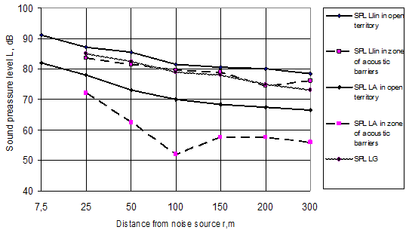
Fig. 1. The range of the total sound pressure level (L_{LIN}, dB) and A and G – weighting sound pressures (L_{A}, dBA) and (L_{G}, dBG) depending on the distance (r, m) from traffic noise source on open field and acoustic barrier of 2,5 m high mounted. (8 pt., Centered, Normal)
These essential attitudes used to characterize environmental acoustic noise by introducing index to assess sound energy domination in appropriate frequency bands (LF, MF or HF). That index was proposed by Blazier (Tocci, 2000) for assessment of quality of room acoustic noise to speech communication (SC).
Since the sensibility of hearing depends on frequency, the audible sound is grouped into the three frequency bands: low, middle and high frequency and denoted as LF, MF and HF, respectively.
The sound in those bands that is being perceived is identified as "rumble", “roar” and “hiss”.

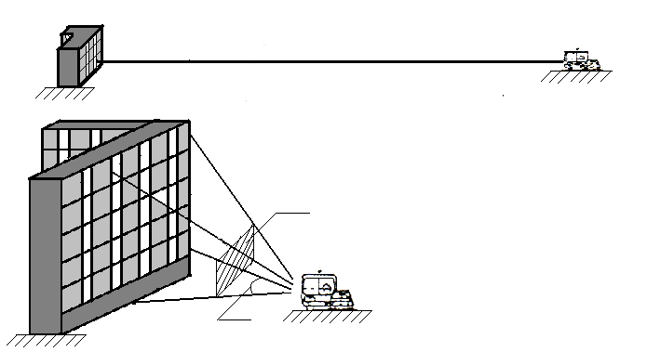
W_{ij}
Θ
Ω
I_{ij} K_{ij}
W₀
MT
I_{x} K_{x}
r
Fig.2. The point and line the sound sources, acoustic radiation scheme (8 pt., Centered, Normal)

Highlight of the proposed method for the investigation of traffic noise is to provide a reasonable approach using qualitative and quantitative factors and the influence at low and very low frequency noise. This is achieved when the weighting and combining of the 31.5, 63 and 125 Hz frequency octave band levels is used to determine a lower frequency band closely and (L_{LIN}-L_{A}) or (L_{LIN}-L_{C}) weighting levels matching the critical band and level to human hearing in the low and infrasonic sound frequency.
Conclusions (10 pt, Bold)
1. To characterize the reaction and influence of noise pollution on humans, the parameters of acoustic emission and their amplitude dispersion characteristics with frequency (L_{f, oct,} L_{LIN,} L_{A,} L_{C}, L_{G}) the derivatives QAI (equal assessment index), L_{LIN}-L_{A} (low frequency index) were used to determine the conditions of "rumble, roar, hiss" type sound.
2. ....
3. ....
4. ....
5. ....
List of Literature (8 pt, Bold)
- International Standard ISO 7196 – 1995. Acoustics. Frequency –weighing characteristic for infrasonic measurements, pp 1–6, 1995.
- BOON, NE., YAHYA, A., KHEIRALLA, AF. et al. A Tractor-mounted, Automated Soil Penetrometer-shearometer Unit for Mapping Soil Mechanical Properties. Biosystems Engineering, 2005, Vol. 90, Iss. 4, p. 381–396.
- Tocci, G.C. Room Noise Criteria - The State on the Art in the Year 2000. Noise News, 8(3), pp. 106–120, 2000, http://www.ince.org.
- FANGER, P. O. Thermal. – Copenhagen: Danich Technical Press, 1970, 241 p.

14 pt, Section Break
Name Surname (8 pt, Normal)
How to prepare a Manuscript for the Scientific Journal (8 pt, Bold)
Summary (8 pt, Normal)
This document contains instruction for the preparation of manuscripts for the scientific journal (8 pt, Normal, First line 0,6 cm)
Environmental acoustic noise, Sound pressure level, Traffic noise (8 pt, Italic, First line 0,6 cm)
Received in ………, 2021, submitted to printing in ………, 2021 (9 pt, Italic)
Name SURNAME. Vytautas Magnus University Agriculture Academy, Faculty of Agricultural Engineering Institute of Agricultural Engineering and Safety, doctor of technology (technical) sciences, assoc. prof. Address: Studentu g. 15a, LT-53361, Akademija, Kauno r. Lithuania. Tel (+370 37) 75 23 57, e-mail: Name.Surnname@vdu.lt (8 pt, Normal).
Vardas PAVARDĖ. Vytauto Didžiojo universiteto Žemės ūkio akademijos Žemės ūkio inžinerijos fakulteto Žemės ūkio inžinerijos ir saugos instituto technologijos (technikos) mokslų daktaras, docentas. Adresas: Studentų g. 15a, LT-53361, Akademija, Kauno r. Tel. (8 37) 75 23 57, el. paštas: Vardas.Pavarde@vdu.lt (8 pt, Normal).

